## Devicelist generated

Once you have made an import the system will make a “devicelist_generated”. In this file you will find all the changes, faults, etc. that the system found. These are changes that are the differences between your devicelist import and the existing configuration. Also if you have made a mistake in the devicelist, it will be noted here so you can check whether you have to change something. The devicelist_generated will look like the following figure:

*: Open the devicelist_generated (or the other generated files which are all HTML-files) with right-click>open with> excel program.*

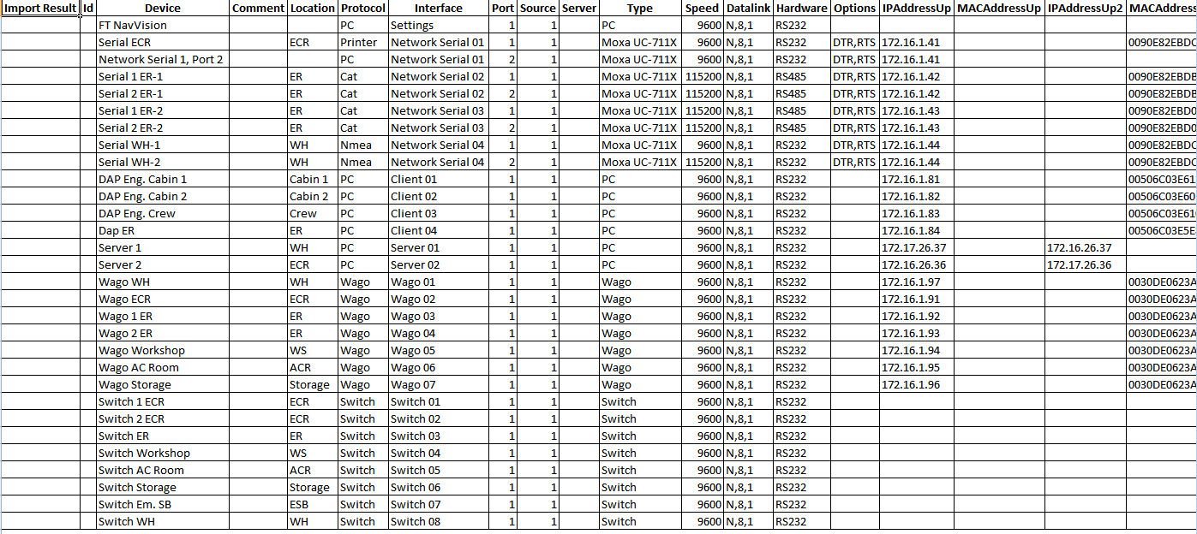

Figure 12‑5: devicelist_generated good

This is of course when the devicelist was good in the first place. This is the kind of devicelist_generated that you want to get back, because then you know you did well. When you have made a mistake you will find a comment (with a color) in the first column import result”. You can have something like the following figure:

|  |  |
| --- | --- |
| Field | Description |
| Comment | Comment that something is different in the field |
| Changed | Notice that something has changed |
| Failed | Critical failure somewhere in the field |
| Missing | Field tag is missing |
| New | Field is added since last import |

Figure 12‑6: Fault codes

The “comments” are merely there to make you aware that there is a small problem. Just check the line if there is an inconsistency in words or something. Sometimes it doesn’t even matter that there is a comment while you can deliberately made a difference in something. It doesn’t really affect he program.

The “changed” is there to warn you that there is something altered between the original configuration and the import. It can be two ways. Maybe NavVision changed something because the program noticed that you made a mistake. Maybe you mixed up a protocol or whatever. The fault in the row behind the import result will also be colored yellow. Sometimes there is something changed that differs between the original configuration and what you imported with the sensorlist.